AHCI Project Report: Yale School of Art Website Redesign

Group Members:
23K-0724 Roshaan Haider
23K-0668 Mujtaba Khan
23K-0562 Affan Rehman
Project Title:
Yale School of Art Website Interface Redesign
Project Aim:
The aim of this project was to redesign the Yale School of Art website by improving its usability, visual consistency, readability, navigation, and overall user experience while keeping the original identity of the website.
Before Redesign
The original website had a very experimental and artistic appearance, but it created several usability problems.
Main issues identified:
- The interface looked cluttered and confusing.
- Background images and text overlapped, making content hard to read.
- Colors were inconsistent and did not follow a proper visual theme.
- Buttons and links were not visually balanced.
- Navigation was present, but the overall structure was not clear.
- Too much information appeared on one screen.
- The design looked creative but not professional or user-friendly.
Before Redesign Image:
This image shows the original Yale School of Art website. It has strong artistic identity, but the layout, colors, and readability create usability problems.
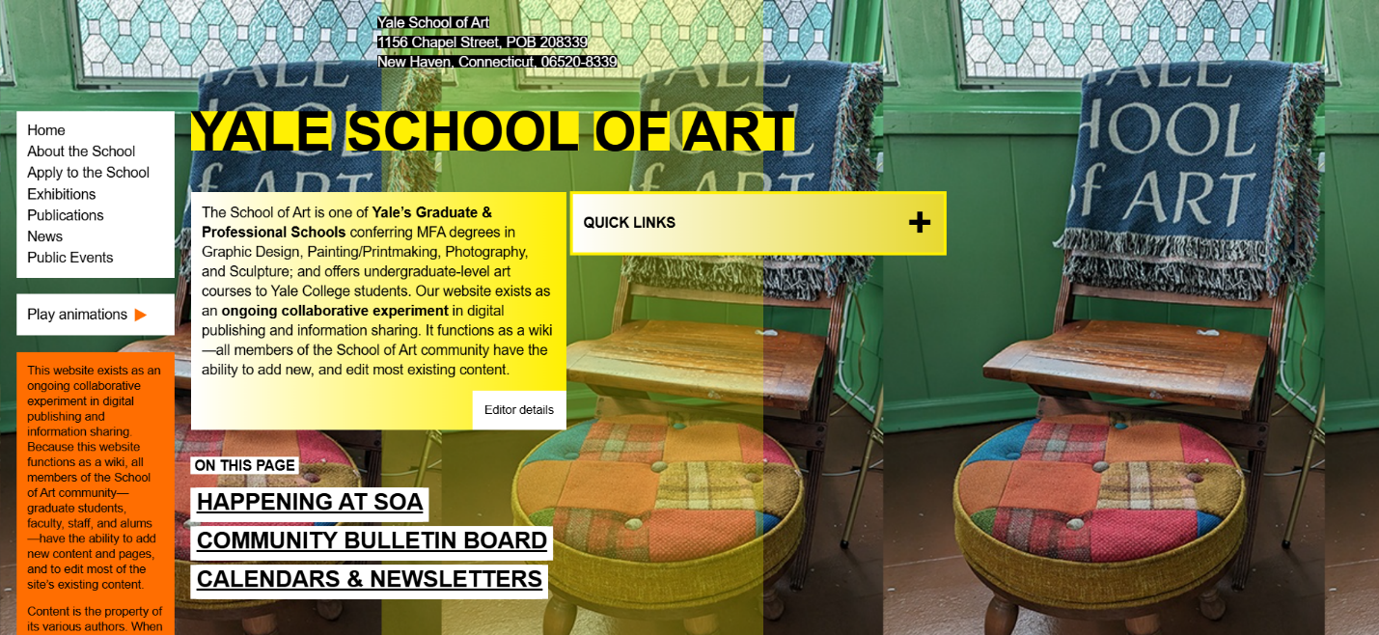

After Redesign
In the redesigned version, the website was improved while keeping the Yale School of Art identity. The new design looks cleaner, more professional, and easier to use.
Main improvements:
- A proper Yale School of Art logo was added.
- A consistent navigation bar was created.
- Separate pages were created for Home, About, Apply, Exhibitions, Publications, News, and Public Events.
- Buttons were redesigned to look clear and clickable.
- Background images were improved and matched with each page.
- Text readability was improved with better spacing and contrast.
- The layout became more structured and professional.
- The website became easier to understand for new users.
After Redesign Image:
This image shows the improved version. It has a cleaner header, better navigation, professional layout, consistent colors, and clearer call-to-action buttons.

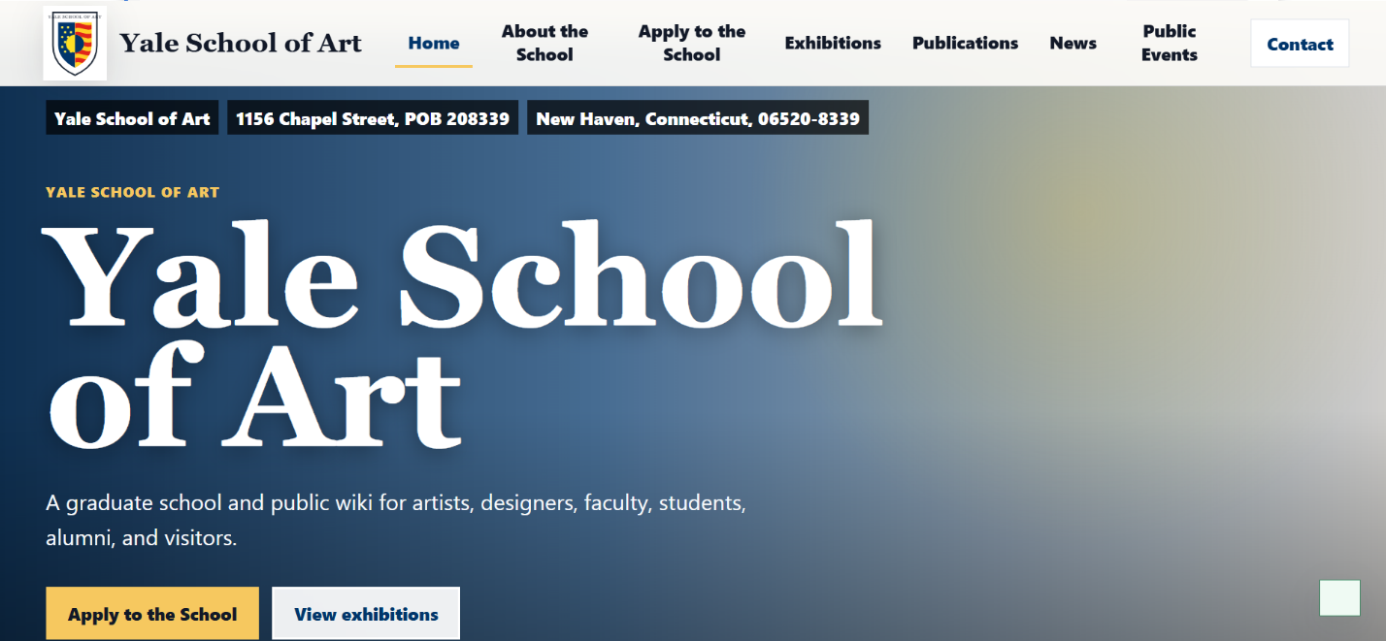

Technology Used
The project was built using:
- React for building the user interface.
- TypeScript for safer and more structured code.
- CSS for custom styling, layout, colors, responsiveness, and page design.
- Vite for the frontend development environment.
- Node.js for running the local preview server.
- Lucide React Icons for modern UI icons.
HCI Principles Applied
Consistency:
The website now uses consistent colors, typography, buttons, spacing, and navigation across all pages.
Visibility of System Status:
The active page is highlighted, and forms show feedback messages after submission.
Recognition Rather Than Recall:
Important pages are visible in the navigation, so users do not need to remember where information is located.
User Control and Freedom:
Users can move between pages using the navbar, quick links, search, and buttons.
Aesthetic and Minimalist Design:
The clutter was reduced, and the layout now focuses on important content only.
Accessibility:
Better contrast, readable fonts, clear buttons, and responsive layout improve accessibility.
Error Prevention:
Clear forms, labels, and buttons reduce confusion and user mistakes.
Workflow Followed
- Studied the original Yale School of Art website.
- Identified usability and interface problems.
- Planned a cleaner structure with multiple pages.
- Designed a consistent visual theme using Yale-inspired colors.
- Added a proper logo and professional page backgrounds.
- Created working navigation and interactive buttons.
- Added search, quick links, forms, and checklist features.
- Improved responsiveness for different screen sizes.
- Compared before and after designs to evaluate improvement.
Conclusion
The redesigned Yale School of Art website improves the original interface by making it more professional, readable, consistent, and user-friendly. The project successfully applies AHCI/HCI principles while keeping the creative identity of the original website. The final result is a cleaner and more usable website that supports both visual appeal and practical user interaction.

